E-Safety Policy
______________________________________________________

E-Safety encompasses Internet technologies and electronic communications such as mobile phones and wireless technology.
______________________________________________________

Policy Aim
YMCA Manchester’s E-Safety Policy highlights the need to educate children and young people about the benefits and risks of using new technology and provides safeguards and awareness for users to enable them to control their online experiences.

Keeping Safe Online:
Guidelines for Students whilst attending YMCA Manchester
The Internet is provided for you (the student) to conduct research and enhance your educational experience. Access to the Internet is a privilege, not a right, and hence requires responsibility.
- We own the computer network and can therefore set rules for its use.
- It may be a criminal offence to use a computer or network for a purpose not permitted by YMCA Manchester.
- Irresponsible use may result in the loss of network or Internet access.
- All network and Internet use must be appropriate to education.
- Social networking sites such as Facebook are not to be accessed on our laptops.
- Copyright and intellectual property rights must be respected.

Guidelines for Students outside of YMCA Manchester
- Don’t post, send or share anything you wouldn’t want your parents, teachers, future employers to see.
- Keep your private information private – do not give out personal details online like your birthday or address, even on social networking sites like Facebook.
- Remember to change your passwords regularly.
- Passwords should be completely random and unique, but still memorable. Try using combinations of numbers and letters.
- If you are being bullied or have any issues with e-safety, talk to someone you trust – do not deal with it on your own.
- Tell your parent, carer or trusted adult if someone or something makes you feel uncomfortable or worried or if you or someone you know is being bullied online.
Childnet International works with young people to help make the internet a great and safe place. In the Childnet Hub you’ll find top tips, competitions, blogs and advice to help you to use the internet safely, responsibly and positively. You can also visit the get involved section to have your say on all things internet and new technology related! Go to childnet and kidsmart for further information.

Communication of Policy to Parents/Carers
Parents and Carers will be given the opportunity to sign a Media Consent Form (Appendix A) during induction week. This form can be located in the Parent/Carer Induction Booklet.

Communication of Policy to Students
- Rules for internet access will be posted in classrooms.
- During Induction students will be informed that internet use will be monitored.
- Advice and e-safety information is available to students via the YMCA Manchester Induction Booklet.

Summary
YMCA Manchester is aware of its obligation under laws such as the Data Protection Act and the Computer Misuse Act, and should the need arise will not hesitate to involve the Police or any other relevant authorities.
Appendix A.
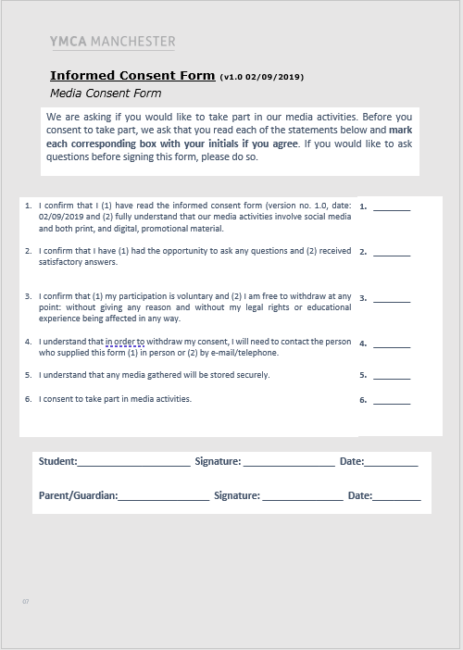
Media Consent Form

