|  |  |  |  |
| --- | --- | --- | --- |
| **Version** | | 4 | |
| **Date approved by CEO** | | September 2018 | |
| **Review Period** | | Ongoing | |
| **Last Review Date** | | November 2024 | |
| **Sources of guidance used** | | ISO 9001 | |
| **Document History** | | | |
| **Version** | **Date** | **Editor** | **Changes made** |
| 1 | September 2018 | M Gandy | Original |
| 2 | September 2020 | M Gandy | General update |
| 3 | January 2023 | P Smith | Review and minor edits |
| 4 | November 2024 | M Corneille | Content edits |

**Informed Consent Form**

*Media Consent Form*

1. **________**
2. **________**
3. **________**
4. **________**
5. **________**
6. **________**

1. I confirm that I (1) have read the informed consent form (version no. 1.0, date: 11/09/2018 and (2) fully understand that our media activities involve social media and both print, and digital, promotional material.
2. I confirm that I have (1) had the opportunity to ask any questions and (2) received satisfactory answers.
3. I confirm that (1) my participation is voluntary and (2) I am free to withdraw at any point: without giving any reason and without my legal rights or educational experience being affected in any way.
4. I understand that in order to withdraw my consent, I will need to contact the person who supplied this form (1) in person or (2) by e-mail/telephone.
5. I understand that any media gathered will be stored securely.
6. I consent to take part in media activities.

We are asking if you would like to take part in our media activities. Before you consent to take part, we ask that you read each of the statements below and **mark each corresponding box with your initials if you agree**. If you would like to ask questions before signing this form, please do so.

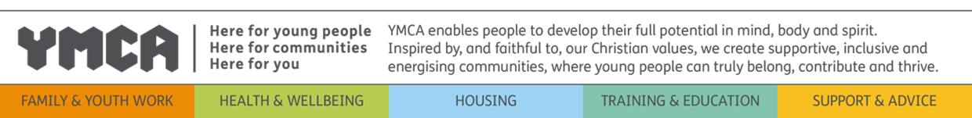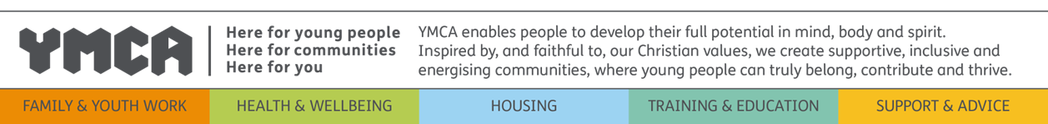

**Student:__________________ Signature: ________________ Date:___________**

**Parent/Guardian:_______________ Signature: _______________ Date:_________**